









Before talking about how images are stored on computers, let’s look at typical computer vision (CV) problems. We will explore what kind of tasks you can solve by using image data.



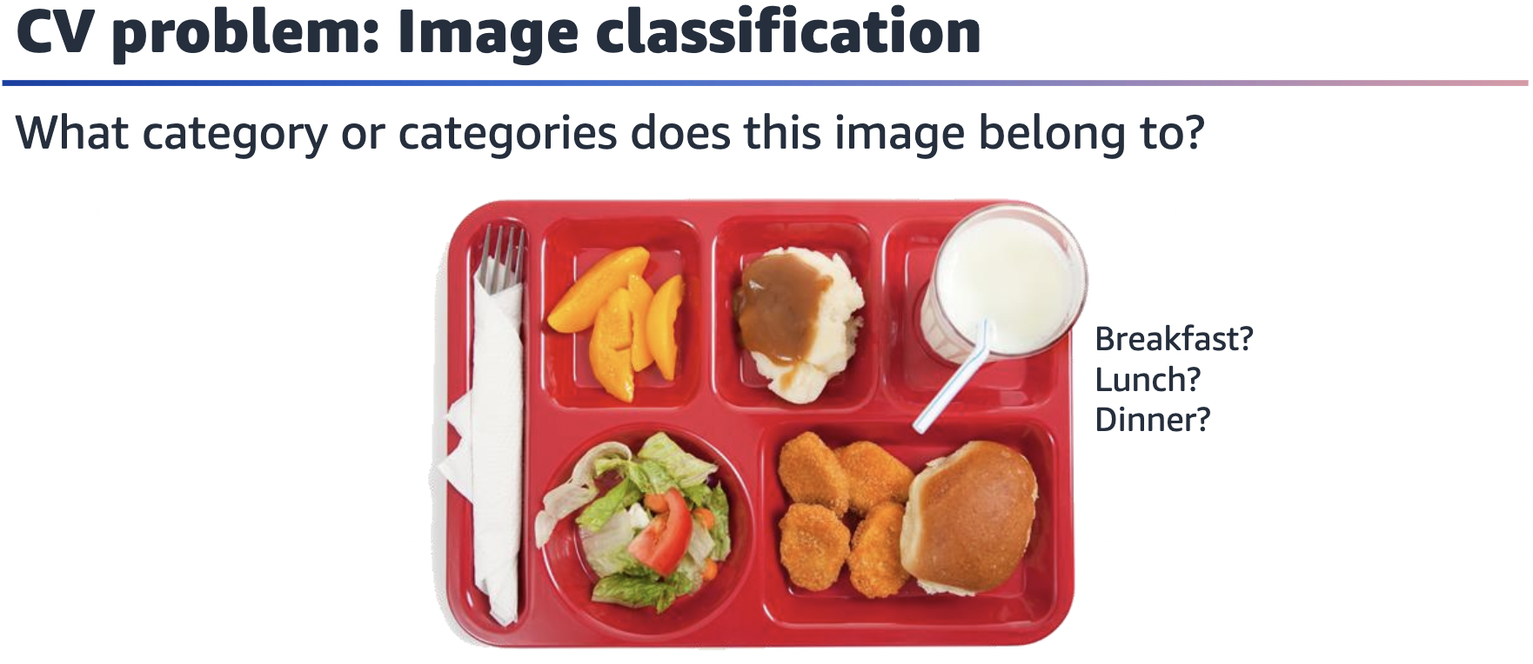

Lunch tray with different foods in each compartment, including a bread roll, chicken nuggets, salad, mashed potatoes, peach slices, a glass of milk, and silverware wrapped in a napkin.

This lesson describes three main types of CV problems. The first and most common

type of CV problem is called image classification. This means providing an image as input and letting the model predict which category the image belongs to, based on a

set of predefined categories. For example, you could classify which meal is shown in

the image on this slide. Another classification problem would be to use CV to identify

when a defect occurs in products on an assembly line.

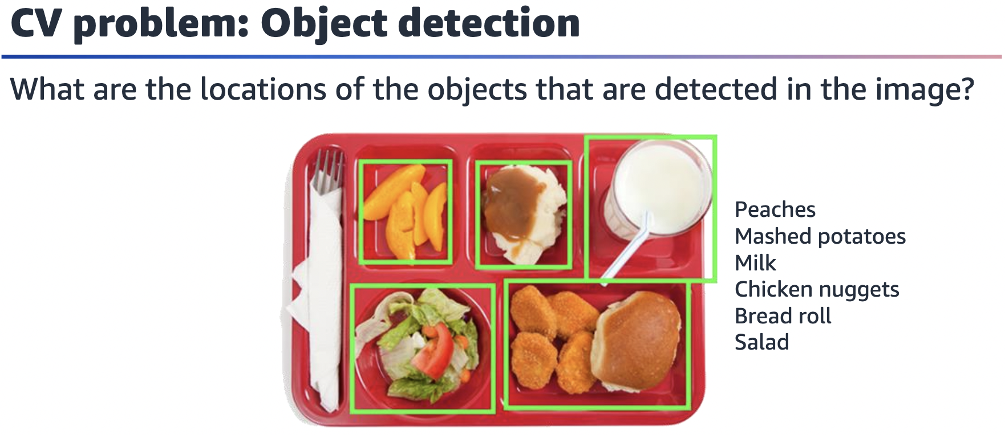

Usually, images contain many objects. Therefore, the second kind of CV problem is object detection. During object detection, bounding boxes are created around objects

to define where they are in an image and how big they are. Object positioning can be

important, such as specifying the location of a defect on a product. Object detection

is often a necessary step before image classification.

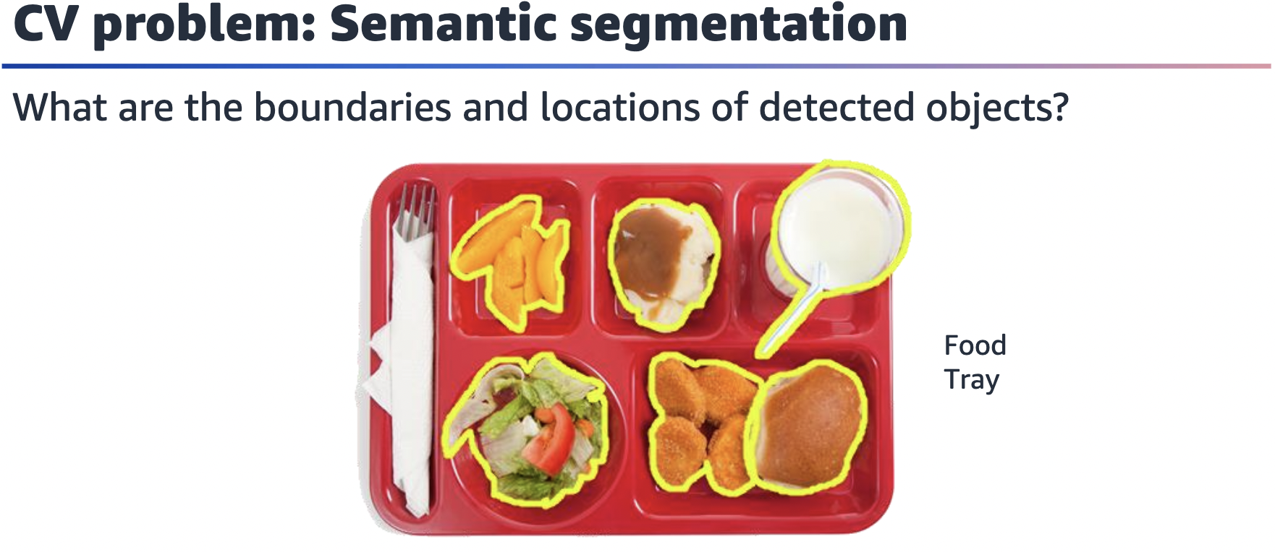

Finally, an image could contain different scenes. Some objects might be in the

foreground, and some might be in the background. Semantic segmentation separates

those scenes and can be done using unsupervised techniques. As an example, this

kind of task is important for self-driving cars, which need to distinguish between scenes, such as the sidewalk, the road, and a building.



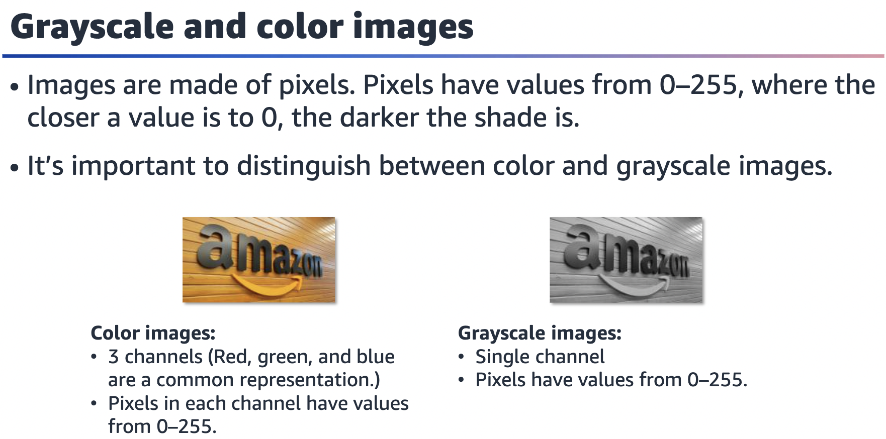

Images are made of pixels with a certain value range. Cameras can detect incoming

light in different wavelengths. To create a color image, a sensor records incoming

(reflected) light in different wavelengths. The most common choice of colors is red,

green, and blue. By recording light intensity ranging from 0 – 255 in those three channels, it’s possible to create a color composite image. With the RGB range,

16,777,216 possible colors can be created.

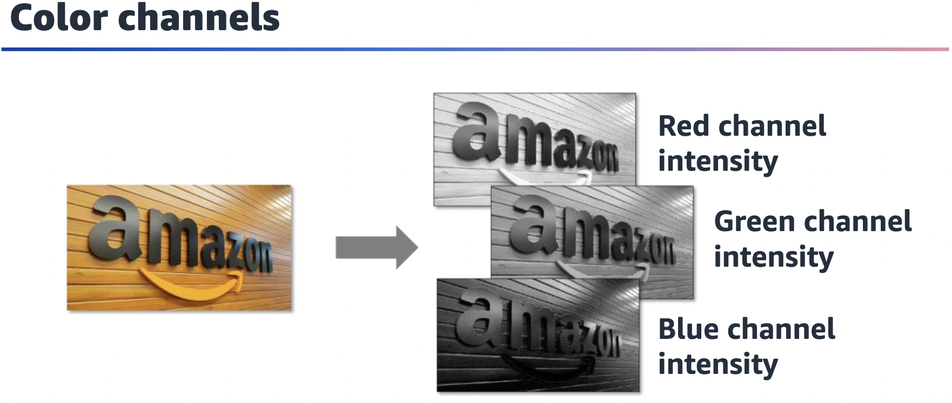

This slide provides an example of what the individual color channels look like, shaded

according to that color’s intensity. You can simply open color images on your computer, but ML libraries actually need to ingest each channel of the image separately.

When an image is split into different color channels, the results look like grayscale

images, but the intensity corresponds to the amounts of red, green, and blue, respectively. A red color channel image that shows high intensity (which is represented visually as being almost white) means that the image has a high intensity of red.

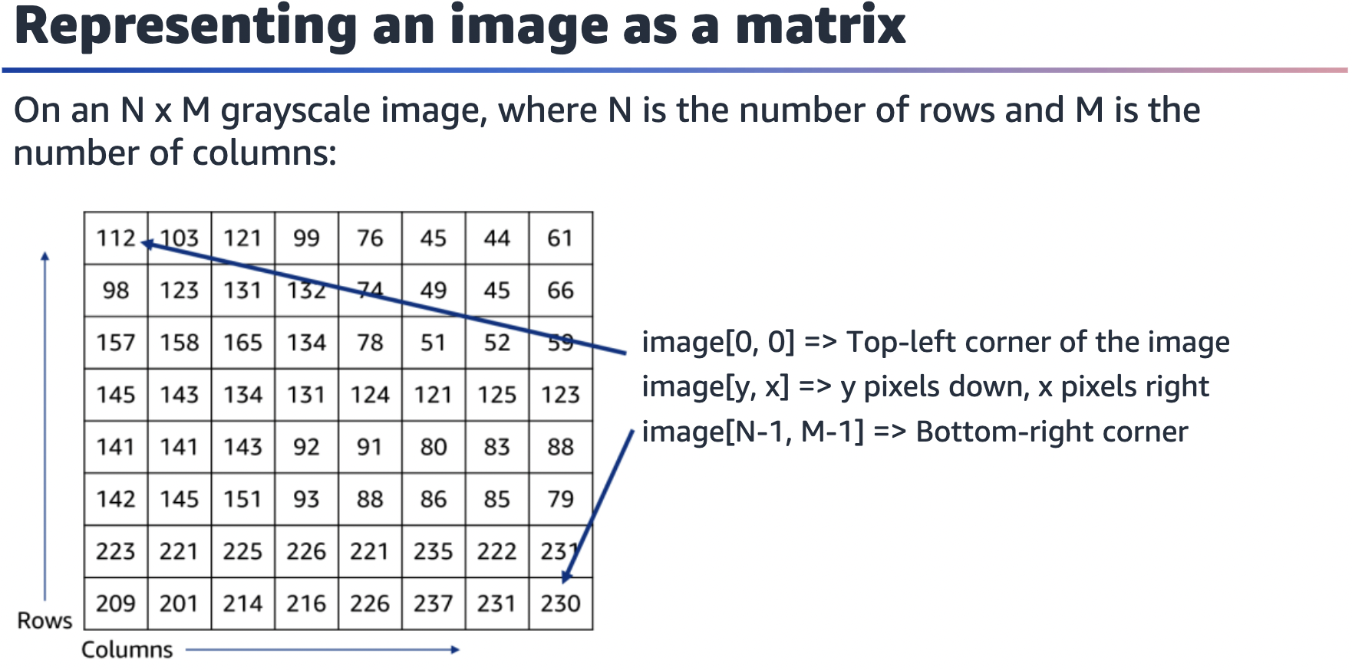

How does an image translate to something that a computer can understand? You can

read out the light intensity values as they were recorded on the sensor of the camera

and store them in a matrix. The position of the pixel refers to the same position in the

image. For example, the top-left pixel in the matrix corresponds to the top-left corner

of the image.

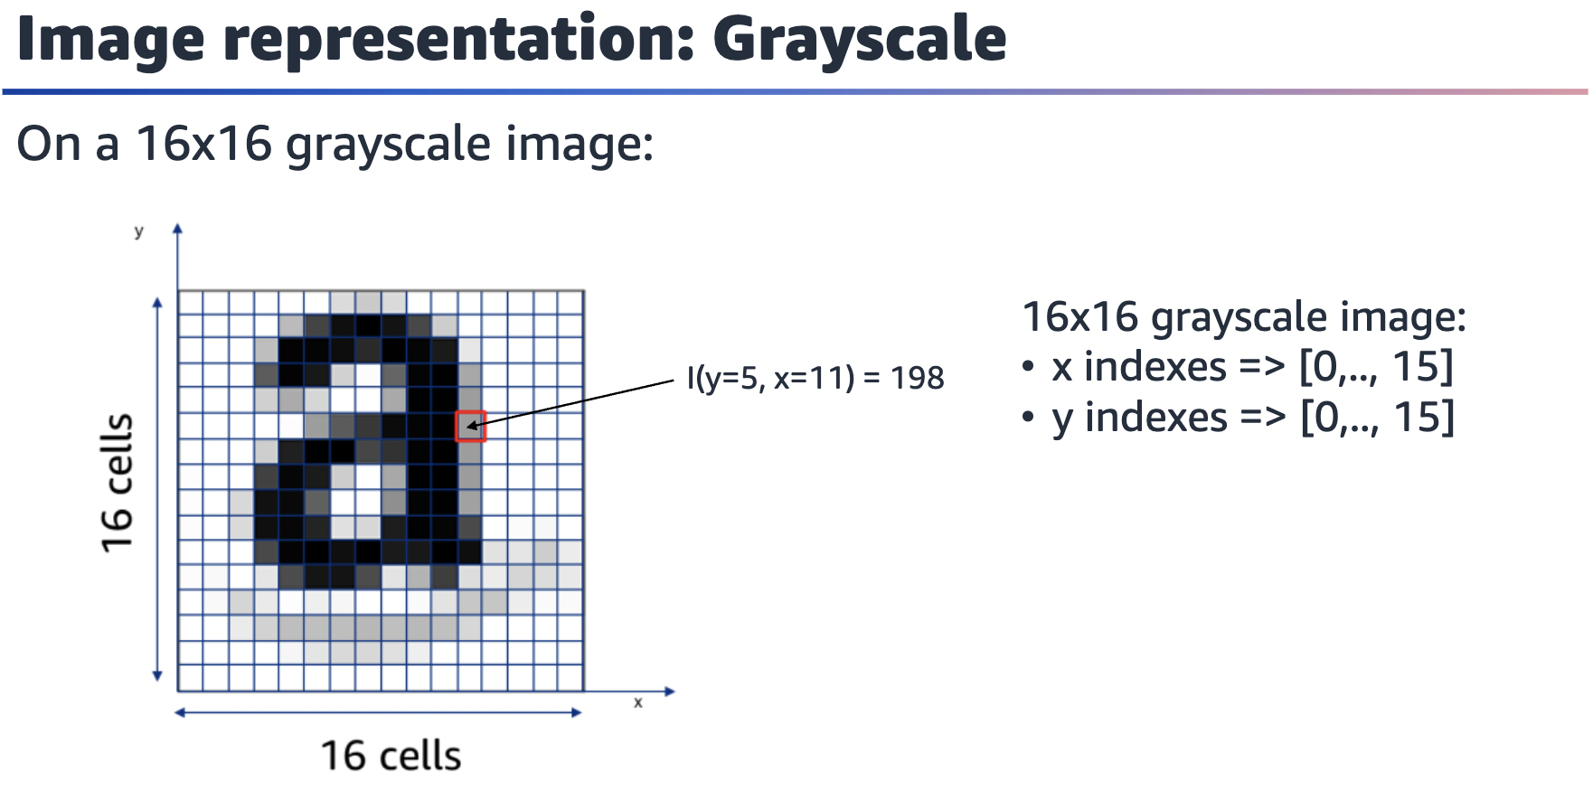

This slide provides an example of a grayscale image with a size of 16x16 pixels. Given

a certain row and column, you can access pixels individually to inspect what value (0-255) any given pixel has.

In this example, row 5, column 11 is a gray pixel with a value of 198 (which is dark but

not quite black, which has the value 255). By looking at an image pixel by pixel, you

can see that areas of the same color form when neighboring pixels have similar

values. Contrast occurs when neighboring pixels have different values.

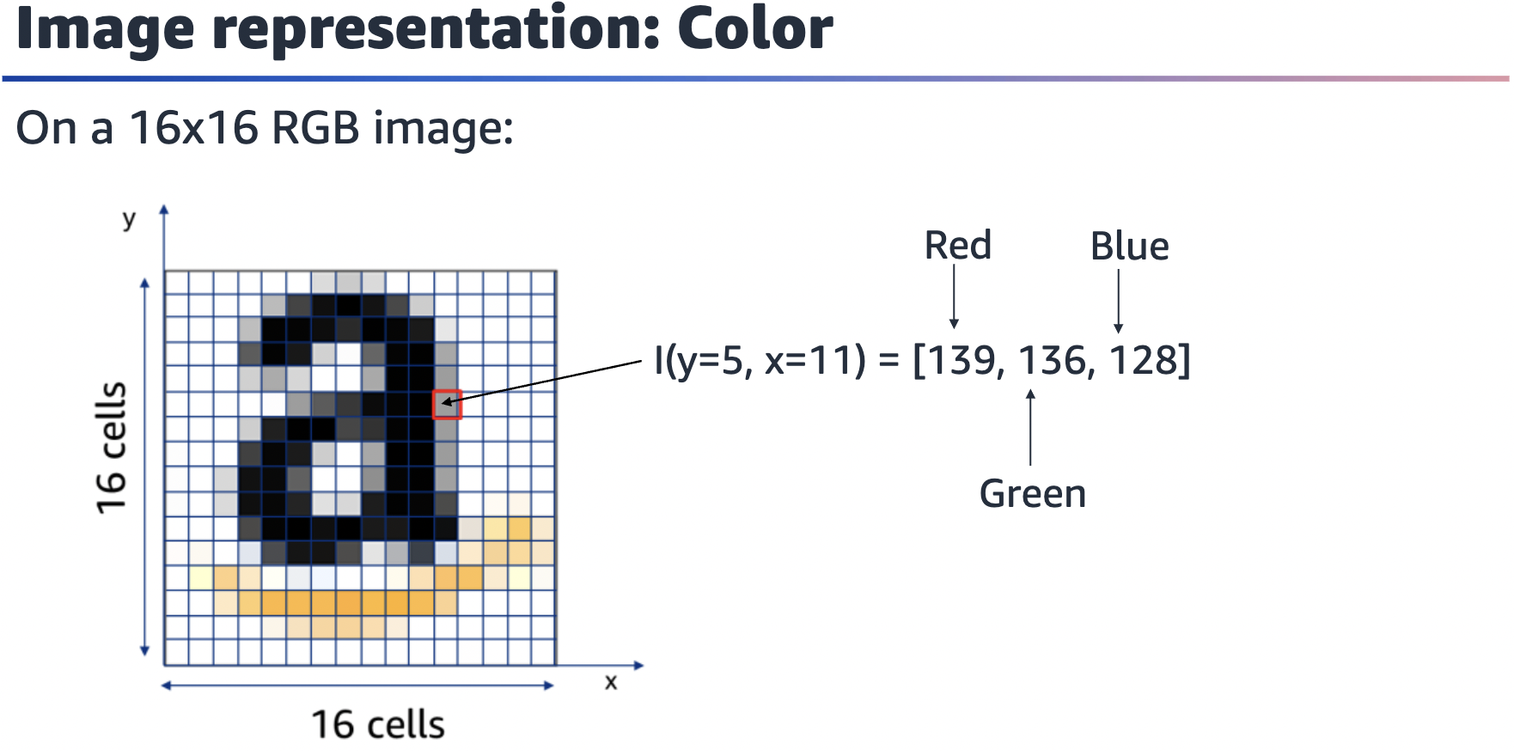

A color image needs to be separated into its different color channels.

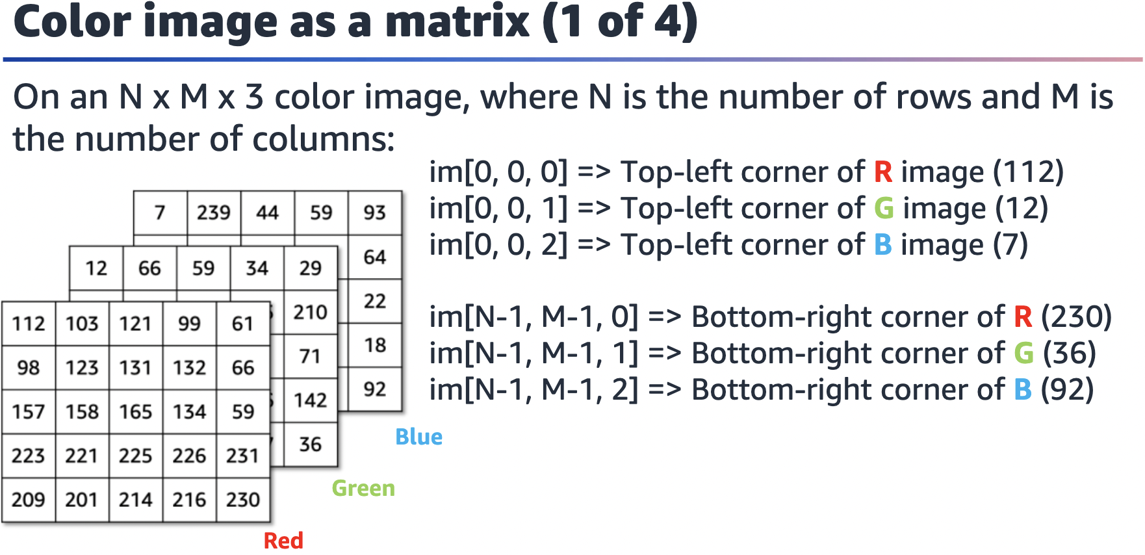

In its decomposed form, a color image looks like an N x M x 3 matrix, where N is the

number of rows and M is the number of columns. The 3 represents the 3 color channels, red, green, and blue.

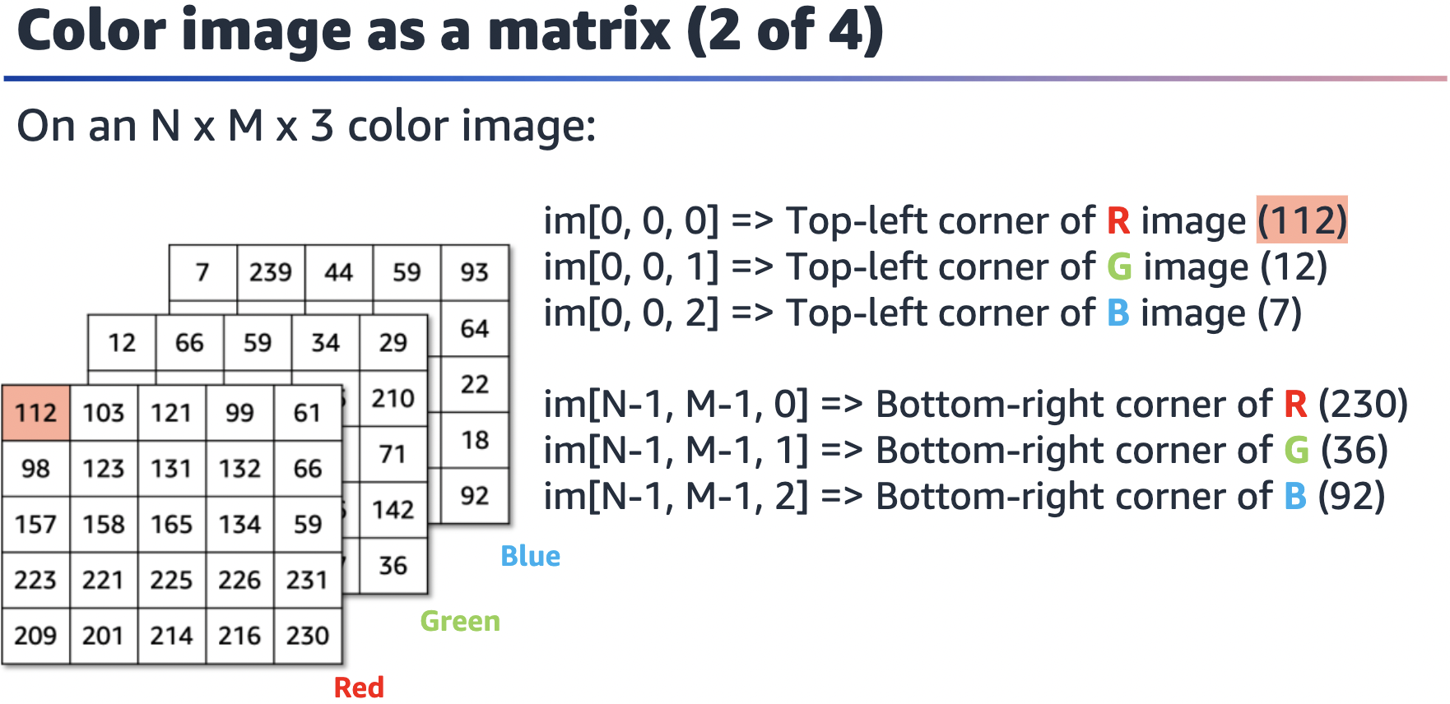

On this slide, a pixel in the red channel is highlighted.

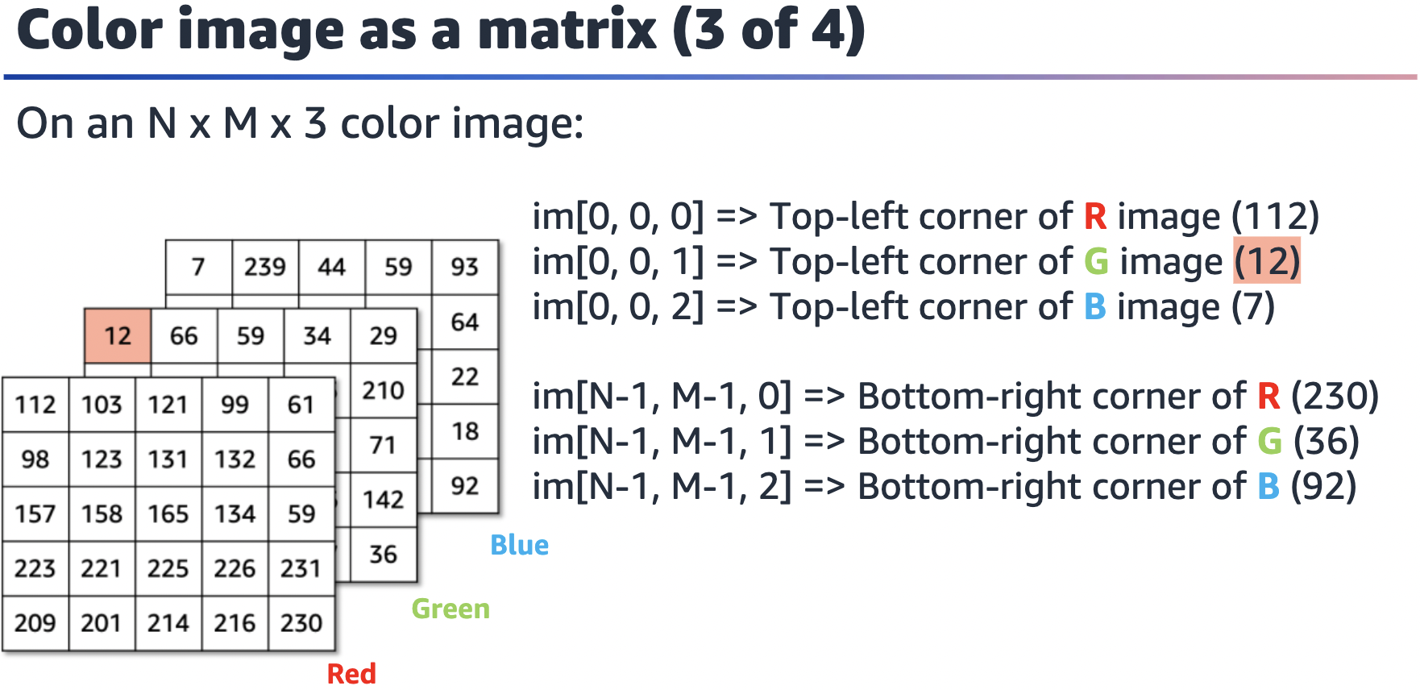

Next, a pixel in the green channel is highlighted.

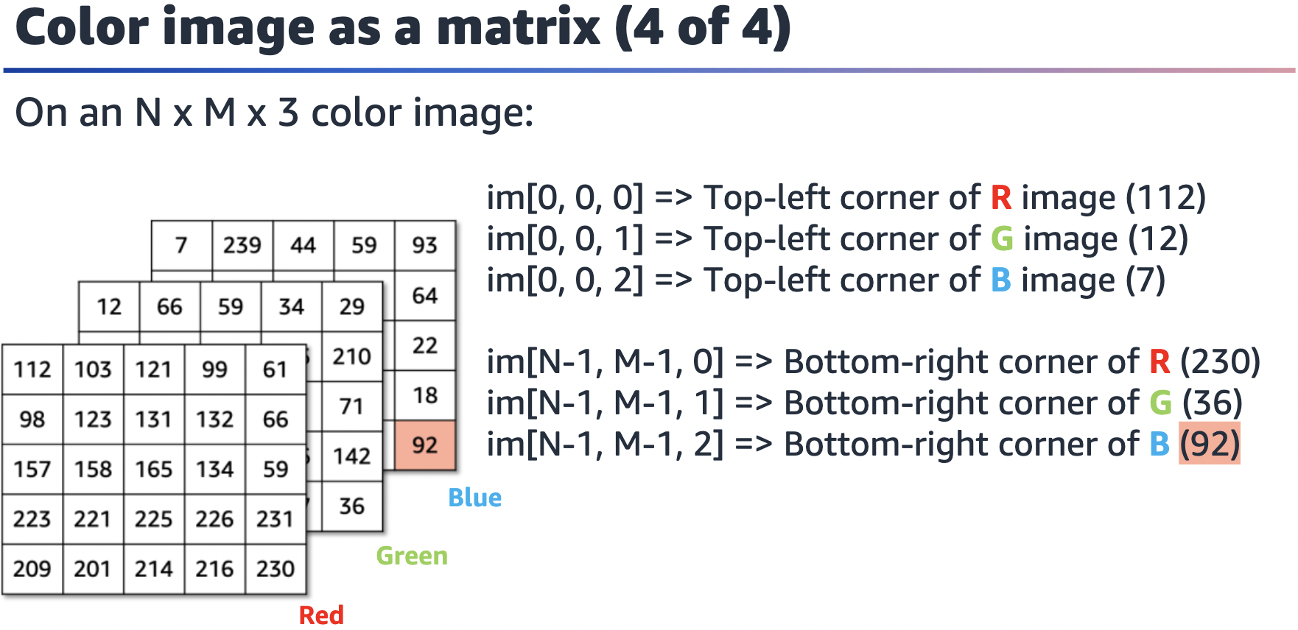

And finally, a pixel in the blue channel is highlighted.

